The History of Halloween

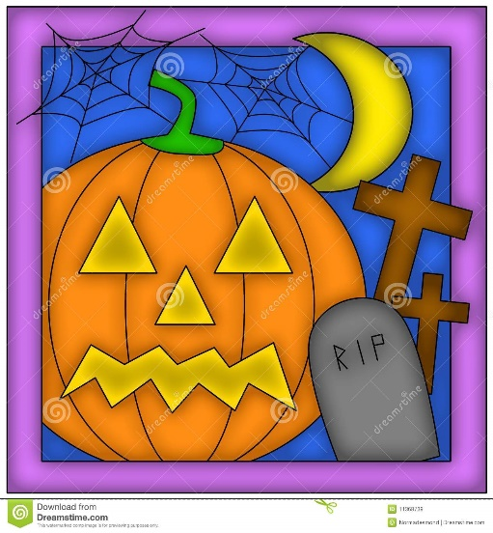
A great number of people consider Halloween to be an American holiday. In reality, it originates from the Celts of Ireland. These days, people do not do what the old Celts did in the past. They do not have a big meal before the winter starts and do not leave their houses cold, without light during the night, hoping to stop spirits wanting to live there. It was believed that the souls of dead people could come back if they find a person to stay in. Nevertheless, wearing scary masks and costumes to make the spirits go away, is an old Celtic tradition.
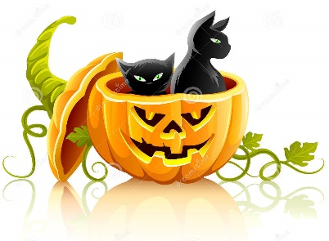
Today, people and especially children enjoy Halloween costume parties. They dress up as witches, vampires and ghosts. Children in masks go from house to house and when the door opens, they say: “Trick or treat!” If they do not get sweets, they do something bad like throwing eggs at the house.
The classic symbols of Halloween are horror characters: black cats, spiders, witches and ghosts and big orange pumpkins. Great Britain and the USA celebrate Halloween every year on the last day of October.
Answer the following questions in full sentences.

1. Who celebrates Halloween?
____________________________________________________________________2. Where does Halloween originate from?
____________________________________________________________________
3. What are the symbols of Halloween?
___________________________________________________________________
4. When do people celebrate it?
___________________________________________________________________
5. What do people wear to scare the spirits?
___________________________________________________________________

